**Christopher King**

**2018141521058**

**Applied Fluid Mechanics**

**Class Section 01**

**06/03/2021**

# **Problem 12.34**

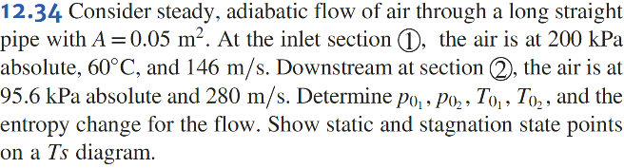

**Solution:**

The - diagram is shown below:

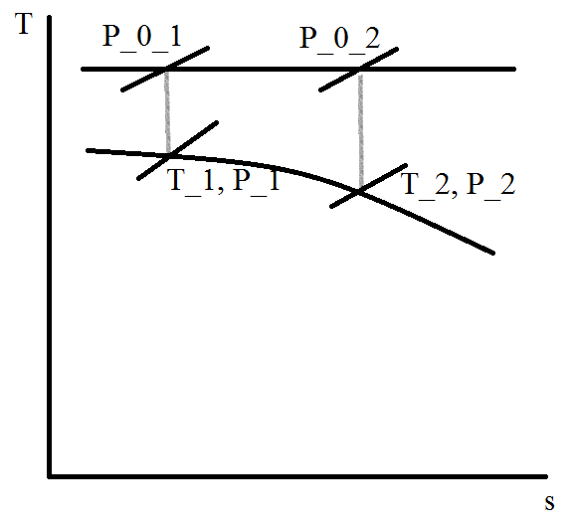

# **Problem 12.38**

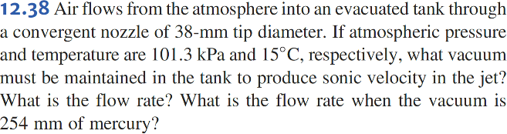

**Solution:**

For

# **Problem 12.43**

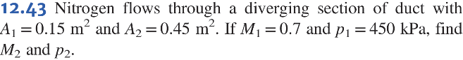

**Solution:**

# **Problem 12.46**

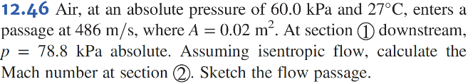

**Solution:**

The - diagram is shown below:

# C:\Users\Administrator\Desktop\1212212.png